Spring Core and Maven Hands On

**Exercise 1: Configuring a Basic Spring Application**

**Scenario:**

Your company is developing a web application for managing a library. You need to use the Spring Framework to handle the backend operations.

**Steps:**

1. **Set Up a Spring Project:**
   * Create a Maven project named **LibraryManagement**.
   * Add Spring Core dependencies in the **pom.xml** file.
2. **Configure the Application Context:**
   * Create an XML configuration file named **applicationContext.xml** in the **src/main/resources** directory.
   * Define beans for **BookService** and **BookRepository** in the XML file.
3. **Define Service and Repository Classes:**
   * Create a package **com.library.service** and add a class **BookService**.
   * Create a package **com.library.repository** and add a class **BookRepository**.
4. **Run the Application:**
   * Create a main class to load the Spring context and test the configuration.

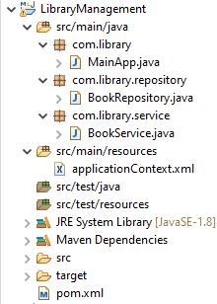

**Pom.xml**

<project xmlns="http://maven.apache.org/POM/4.0.0"

xmlns:xsi="http://www.w3.org/2001/XMLSchema-instance"

xsi:schemaLocation="http://maven.apache.org/POM/4.0.0

http://maven.apache.org/xsd/maven-4.0.0.xsd">

<modelVersion>4.0.0</modelVersion>

<groupId>com.example</groupId>

<artifactId>JUnitDemo</artifactId>

<version>0.0.1-SNAPSHOT</version>

<dependencies>

<!-- Spring Core Context Dependency -->

<dependency>

<groupId>org.springframework</groupId>

<artifactId>spring-context</artifactId>

<version>5.3.34</version> <!-- Use latest if needed -->

</dependency>

</dependencies>

<build>

<plugins>

<plugin>

<artifactId>maven-compiler-plugin</artifactId>

<version>3.8.1</version>

<configuration>

<source>1.8</source>

<target>1.8</target>

</configuration>

</plugin>

</plugins>

</build>

</project>

**src/main/resources/applicationContext.xml**

<?xml version=*"1.0"* encoding=*"UTF-8"*?>

<beans xmlns=*"http://www.springframework.org/schema/beans"*

xmlns:xsi=*"http://www.w3.org/2001/XMLSchema-instance"*

xsi:schemaLocation=*"*

*http://www.springframework.org/schema/beans*

*http://www.springframework.org/schema/beans/spring-beans.xsd"*>

<!-- Define Repository Bean -->

<bean id=*"bookRepository"* class=*"com.library.repository.BookRepository"* />

<!-- Define Service Bean and Inject Repository -->

<bean id=*"bookService"* class=*"com.library.service.BookService"*>

<property name=*"bookRepository"* ref=*"bookRepository"* />

</bean>

</beans>

**src/main/java/com/library/repository/BookRepository.java**

**package** com.library.repository;

**public** **class** BookRepository {

**public** **void** saveBook(String bookName) {

System.***out***.println("Saving book: " + bookName);

}

}

**src/main/java/com/library/service/BookService.java**

**package** com.library.service;

**import** com.library.repository.BookRepository;

**public** **class** BookService {

**private** BookRepository bookRepository;

// Setter for Spring to inject

**public** **void** setBookRepository(BookRepository bookRepository) {

**this**.bookRepository = bookRepository;

}

**public** **void** addBook(String bookName) {

System.***out***.println("Adding book: " + bookName);

bookRepository.saveBook(bookName);

}

}

**src/main/java/com/library/MainApp.java**

**package** com.library;

**import** com.library.service.BookService;

**import** org.springframework.context.ApplicationContext;

**import** org.springframework.context.support.ClassPathXmlApplicationContext;

**public** **class** MainApp {

**public** **static** **void** main(String[] args) {

ApplicationContext context = **new** ClassPathXmlApplicationContext("applicationContext.xml");

BookService bookService = context.getBean("bookService", BookService.**class**);

bookService.addBook("The Spring Handbook");

((ClassPathXmlApplicationContext) context).close(); // Clean shutdown

}

}

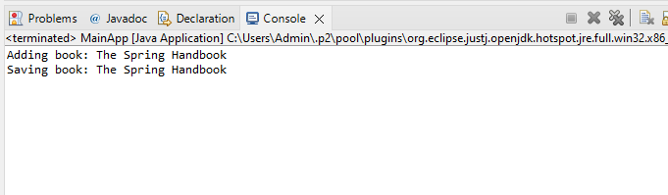

**Exercise 2: Implementing Dependency Injection**

**Scenario:**

In the library management application, you need to manage the dependencies between the BookService and BookRepository classes using Spring's IoC and DI.

**Steps:**

1. **Modify the XML Configuration:**
   * Update **applicationContext.xml** to wire **BookRepository** into **BookService**.
2. **Update the BookService Class:**
   * Ensure that **BookService** class has a setter method for **BookRepository**.
3. **Test the Configuration:**
   * Run the **LibraryManagementApplication** main class to verify the dependency injection.

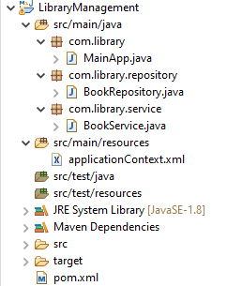

**Pom.xml**

<project xmlns="http://maven.apache.org/POM/4.0.0"

xmlns:xsi="http://www.w3.org/2001/XMLSchema-instance"

xsi:schemaLocation="http://maven.apache.org/POM/4.0.0

http://maven.apache.org/xsd/maven-4.0.0.xsd">

<modelVersion>4.0.0</modelVersion>

<groupId>com.example</groupId>

<artifactId>JUnitDemo</artifactId>

<version>0.0.1-SNAPSHOT</version>

<dependencies>

<!-- Spring Core Context Dependency -->

<dependency>

<groupId>org.springframework</groupId>

<artifactId>spring-context</artifactId>

<version>5.3.34</version> <!-- Use latest if needed -->

</dependency>

</dependencies>

<build>

<plugins>

<plugin>

<artifactId>maven-compiler-plugin</artifactId>

<version>3.8.1</version>

<configuration>

<source>1.8</source>

<target>1.8</target>

</configuration>

</plugin>

</plugins>

</build>

</project>

**src/main/resources/applicationContext.xml**

<?xml version=*"1.0"* encoding=*"UTF-8"*?>

<beans xmlns=*"http://www.springframework.org/schema/beans"*

xmlns:xsi=*"http://www.w3.org/2001/XMLSchema-instance"*

xsi:schemaLocation=*"*

*http://www.springframework.org/schema/beans*

*http://www.springframework.org/schema/beans/spring-beans.xsd"*>

<!-- Define Repository Bean -->

<bean id=*"bookRepository"* class=*"com.library.repository.BookRepository"* />

<!-- Define Service Bean and Inject Repository -->

<bean id=*"bookService"* class=*"com.library.service.BookService"*>

<property name=*"bookRepository"* ref=*"bookRepository"* />

</bean>

</beans>

**src/main/java/com/library/repository/BookRepository.java**

**package** com.library.repository;

**public** **class** BookRepository {

**public** **void** saveBook(String bookName) {

System.***out***.println("Saving book: " + bookName);

}

}

**src/main/java/com/library/service/BookService.java**

**package** com.library.service;

**import** com.library.repository.BookRepository;

**public** **class** BookService {

**private** BookRepository bookRepository;

// Setter for Spring to inject

**public** **void** setBookRepository(BookRepository bookRepository) {

**this**.bookRepository = bookRepository;

}

**public** **void** addBook(String bookName) {

System.***out***.println("Adding book: " + bookName);

bookRepository.saveBook(bookName);

}

}

**src/main/java/com/library/MainApp.java**

**package** com.library;

**import** com.library.service.BookService;

**import** org.springframework.context.ApplicationContext;

**import** org.springframework.context.support.ClassPathXmlApplicationContext;

**public** **class** MainApp {

**public** **static** **void** main(String[] args) {

// Load context

ApplicationContext context = **new** ClassPathXmlApplicationContext("applicationContext.xml");

// Get service bean

BookService bookService = context.getBean("bookService", BookService.**class**);

// Use service

bookService.addBook("Clean Code");

// Close context

((ClassPathXmlApplicationContext) context).close();

}

}

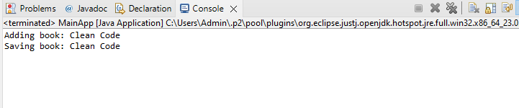

**Exercise 4: Creating and Configuring a Maven Project**

**Scenario:**

You need to set up a new Maven project for the library management application and add Spring dependencies.

**Steps:**

1. **Create a New Maven Project:**
   * Create a new Maven project named **LibraryManagement**.
2. **Add Spring Dependencies in pom.xml:**
   * Include dependencies for Spring Context, Spring AOP, and Spring WebMVC.
3. **Configure Maven Plugins:**
   * Configure the Maven Compiler Plugin for Java version 1.8 in the pom.xml file.

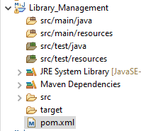

**pom.xml**

<project xmlns="http://maven.apache.org/POM/4.0.0"

xmlns:xsi="http://www.w3.org/2001/XMLSchema-instance"

xsi:schemaLocation="

http://maven.apache.org/POM/4.0.0

http://maven.apache.org/xsd/maven-4.0.0.xsd">

<modelVersion>4.0.0</modelVersion>

<groupId>com.library</groupId>

<artifactId>LibraryManagement</artifactId>

<version>1.0-SNAPSHOT</version>

<dependencies>

<!-- Spring Core & Context -->

<dependency>

<groupId>org.springframework</groupId>

<artifactId>spring-context</artifactId>

<version>5.3.34</version>

</dependency>

<!-- Spring AOP -->

<dependency>

<groupId>org.springframework</groupId>

<artifactId>spring-aop</artifactId>

<version>5.3.34</version>

</dependency>

<!-- Spring Web MVC -->

<dependency>

<groupId>org.springframework</groupId>

<artifactId>spring-webmvc</artifactId>

<version>5.3.34</version>

</dependency>

</dependencies>

<build>

<plugins>

<!-- Compiler Plugin -->

<plugin>

<groupId>org.apache.maven.plugins</groupId>

<artifactId>maven-compiler-plugin</artifactId>

<version>3.8.1</version>

<configuration>

<source>1.8</source>

<target>1.8</target>

</configuration>

</plugin>

</plugins>

</build>

</project>

